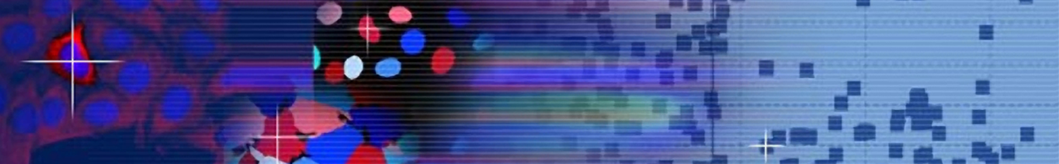

Postdoctoral opening

The Carpenter laboratory (a.k.a. Imaging Platform) at the Broad Institute of Harvard and MIT has an opening for a highly motivated postdoctoral researcher with a strong record of accomplishment in computational research.

Our laboratory develops and applies methods for extracting quantitative information from high-throughput biological images. We are best known for creating and maintaining the open-source CellProfiler project, launched more than 90,000 times per year around the world by biologists quantifying biological processes in images. We collaborate with dozens of biomedical research laboratories to identify disease states, potential therapeutics, and gene functions from microscopy images.

We seek a postdoctoral researcher to join our efforts to glean insights from large collections of images. This work is based on the hypothesis that there is much more information present in microscopy images than is commonly perceived by eye, and that there is a significant lack of knowledge about the appropriate targets for most diseases. We aim to harvest this information through profiling, developing novel methods to characterize cellular populations at single-cell resolution such that similarities and differences among treatments can be described productively. This work has the potential to transform how both the targets and treatments for disease are identified.

We are testing these ideas in several projects, including:
- Predicting how new chemical compounds act in cells
- Identifying and classifying toxicity of compounds destined for clinical trials
- Identifying differences in cell structure between patient cells affected by bipolar disorder or schizophrenia
- Discovering differences among histone deacetylase (HDAC) isoforms, and identifying specific inhibitors against them, for cancer and psychiatric disease
- Identifying gene function from large-scale genome sequencing studies
The ideal candidate will have a very strong computational background and a high level of comfort distilling knowledge from messy data and messy questions. Communicating clearly with the biology domain experts is critical for success in this role. Experience with biological data and imaging data is preferred, as are software development skills (we tend to use Python). Although the major focus of this effort involves machine learning and large-scale data mining, there will be some opportunity for research on image processing algorithms if desired.

Research in the laboratory is supported by the NIH, NSF, and Human Frontiers in Science Program. Please send CV and letter describing interests to anne@broadinstitute.org
http://www.broadinstitute.org/~anne/research.html

